**Creating Simple servlet programme in Netbeans**

1. Create new Web Application Project from the File menu.

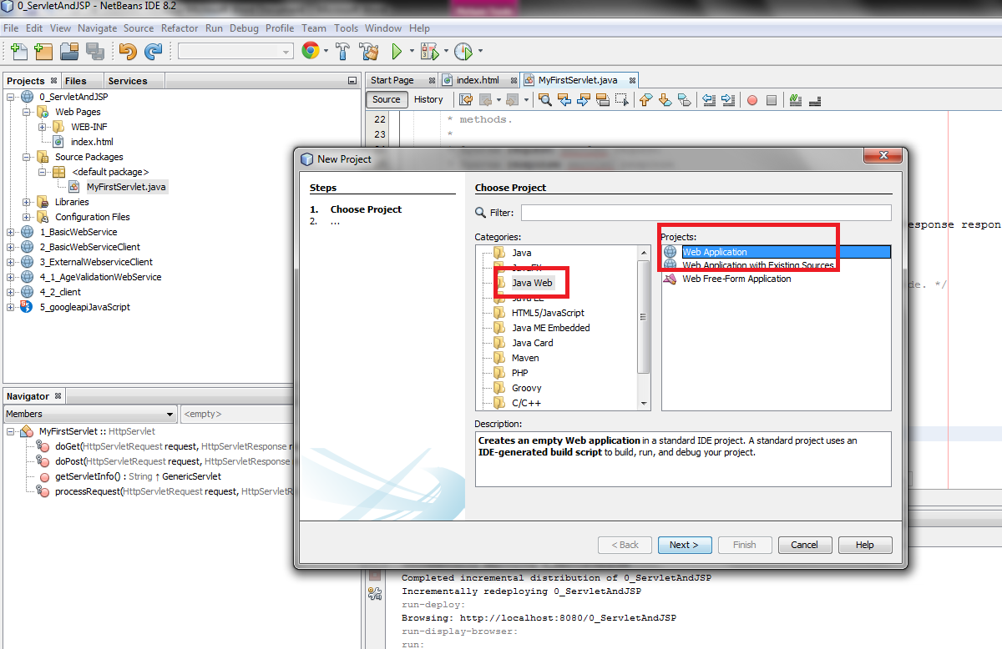

1. Give some project name

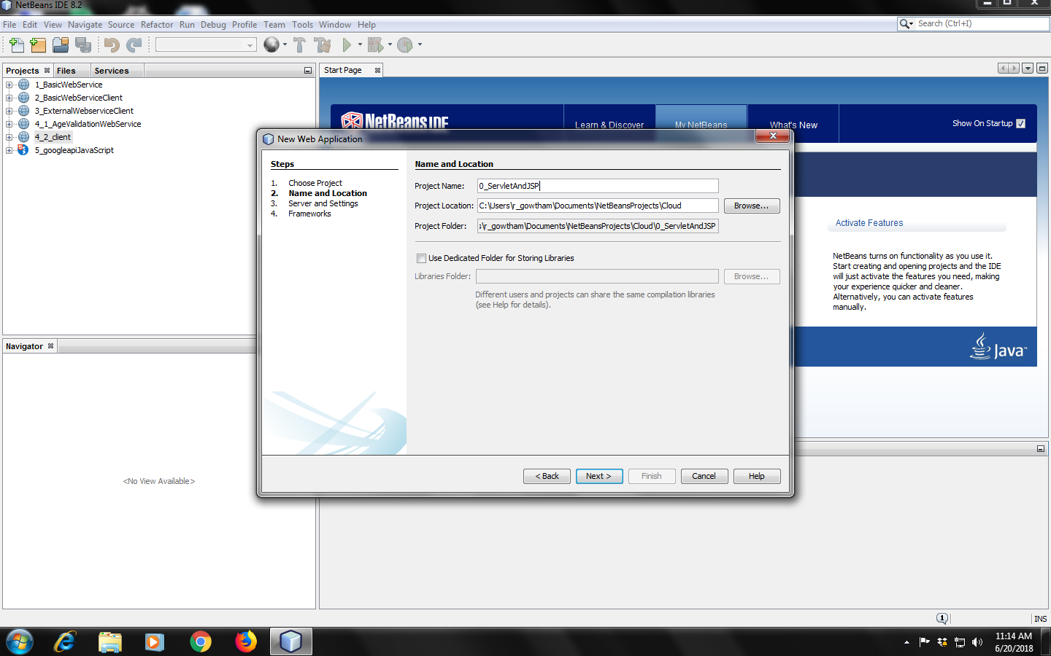

1. Select server option as either Glashfish Server or Apache Tomcat Server

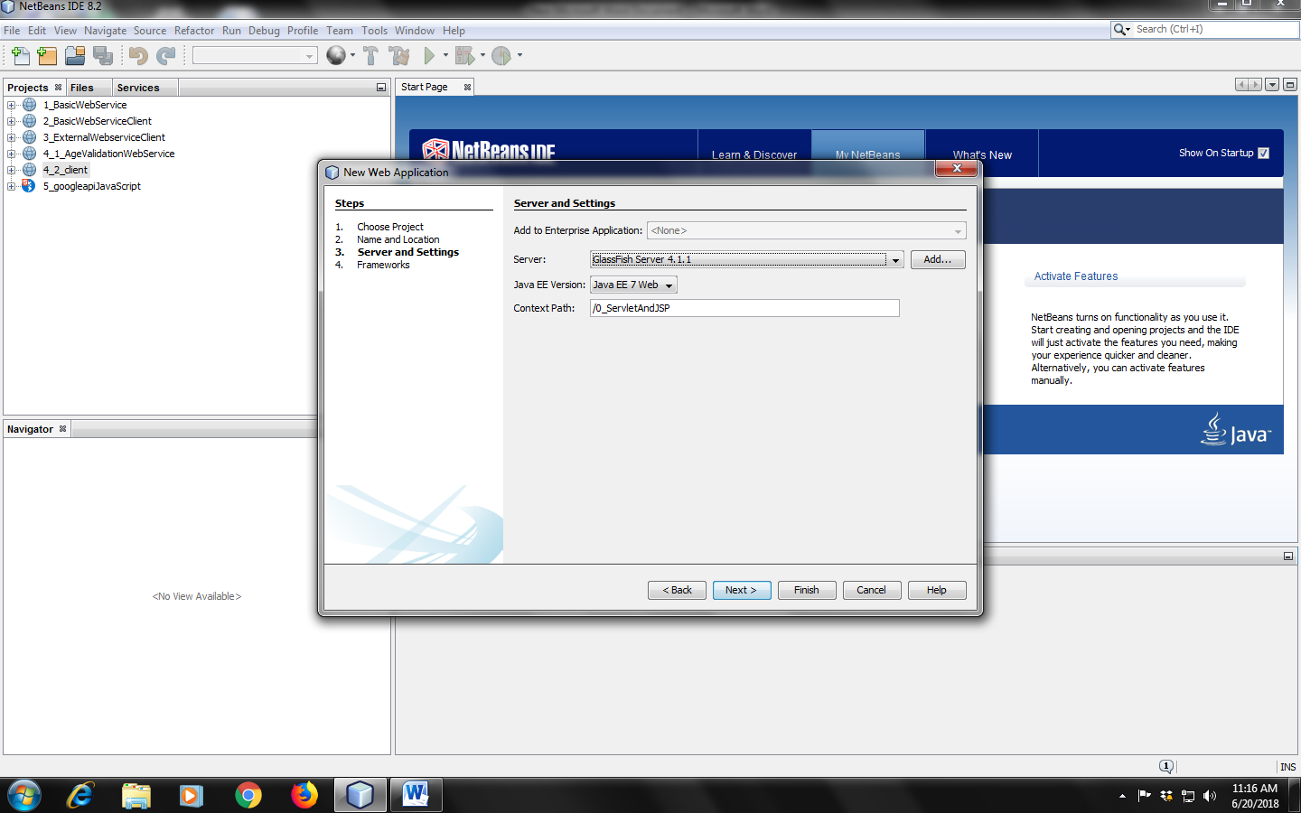

1. Click “Finish” to create a project
2. Right click the project file and select the servlet option.

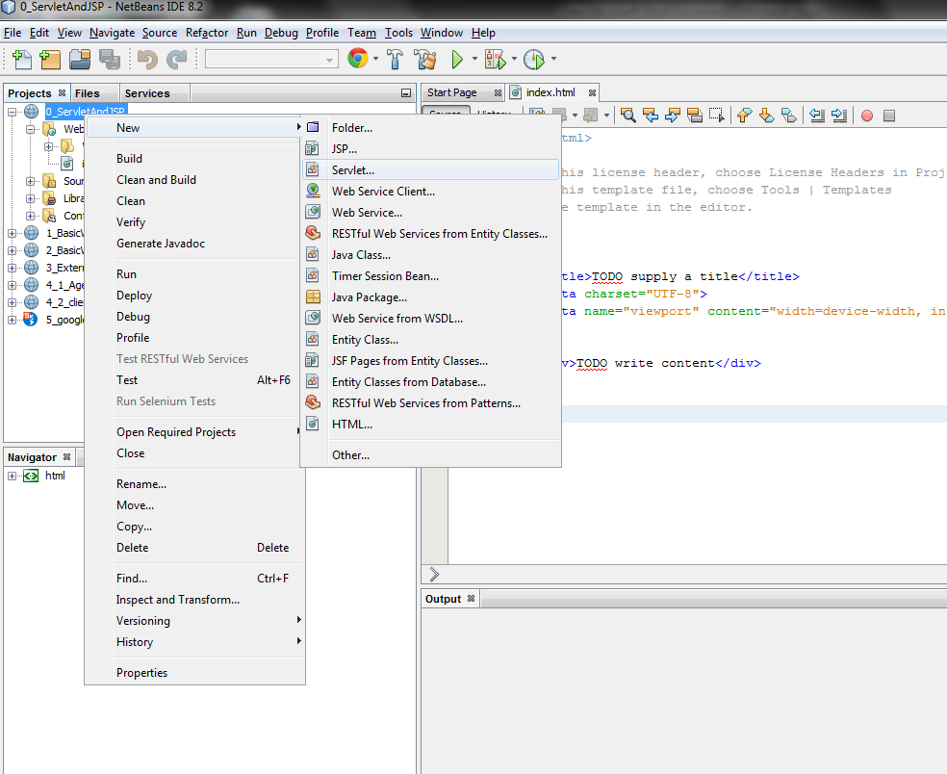

1. Make sure the Class Name is “MyFirstServlet”

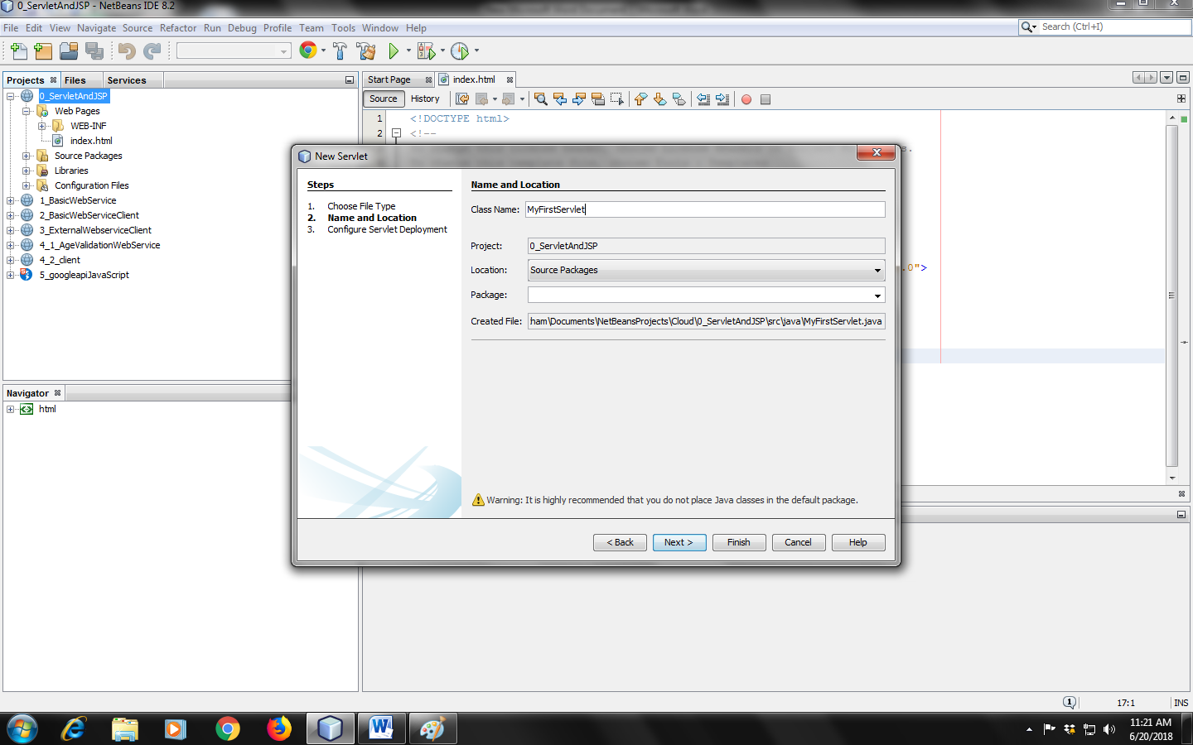

1. Click next to proceed
2. Select the check box “Add information to deployment descriptor” and make sure the URL Pattern is “/MyFirstServlet”

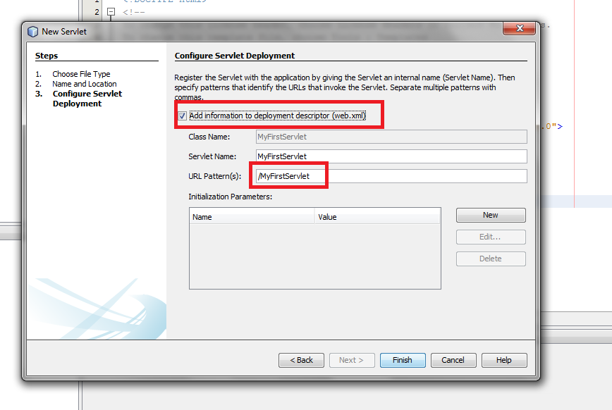

1. Click finish to create the servlet java file
2. Edit following information in the Java file

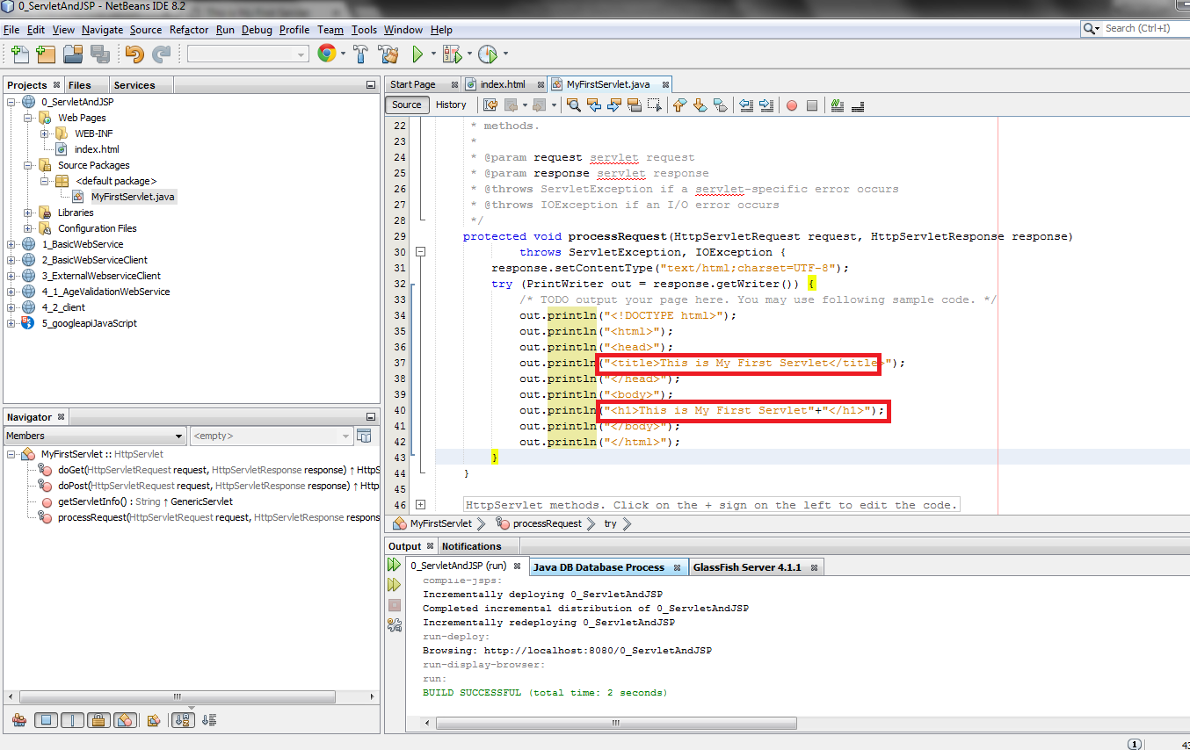

1. Click the Run button to start the GlashFish server and also to execute the servlet program.

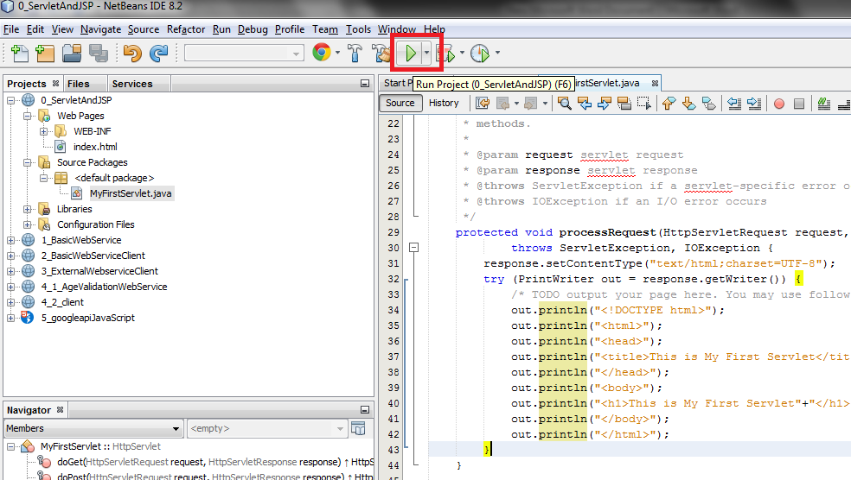

1. The Run will automatically open a web browser and type following path of the servlet in the URL box. In the URL “0_ServletAndJSP” is your file name.

<http://localhost:8080/0_ServletAndJSP/MyFirstServlet>

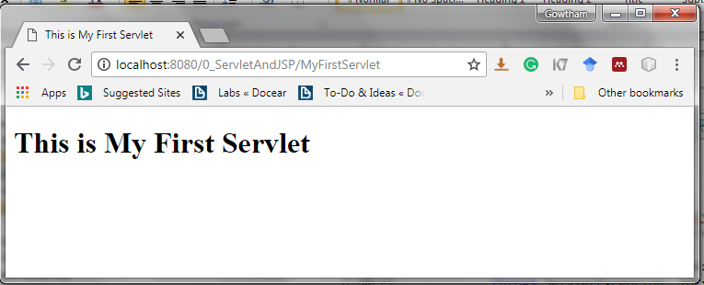

Congratulations !!!